Project Title: THOROTUMBLE – Secure Laundry Reservation System
Course: COS 495 – Interactive Gaming Project
Developer: Robert Dorsey
Semester: Fall 2025

Project Description
ThoroTumble is a small web-based application designed to help students reserve campus laundry machines securely. The application provides a clean UI, QR code integration, and simple navigation. It was developed to simulate real-world software development, team collaboration, and full-stack fundamentals.

Project File Structure
/src
/ui
- index.html
- styles.css
- main.js
/assets
- logo.png
- qr_code.png

/backend
- server.js
- reservations.json

/docs
- user_manual.pdf
- uiux_document.pdf
- test_cases.pdf

Naming Conventions
- Variables use camelCase
- Classes use PascalCase
- File names are lowercase with hyphens
- Functions named according to purpose
  - submitReservation()
  - loadMachineStatus()

Code Comments
Each file contains top-level comments summarizing its purpose.
Examples:
// main.js
// Controls UI interactions, button clicks, and QR code access for the ThoroTumble application.

Repository Link

Repository: https://github.com/RobertDOrsey/thorotumble

2. Test Case Document (Normal, Boundary & Exceptional)

THOROTUMBLE – Software Test Case Document

🟩 Normal Test Cases
Test ID | Description | Input | Expected Result
TC-01 | User reserves machine | Machine #2, Time Slot 4PM | Reservation successful
TC-02 | Load machine list | None | All machines load
TC-03 | Scan QR Code | QR Image | Opens application

🟨 Boundary Test Cases
Test ID | Description | Input | Expected Result
TC-04 | Submit empty form | No machine selected | Show “Please select machine” error
TC-05 | Max character limit | 50-char name | Saves successfully
TC-06 | Min boundary | Blank name | Error message

🟥 Exceptional Test Cases
Test ID | Description | Input | Expected Result
TC-07 | Server offline | Reservation attempt | “Unable to connect” error
TC-08 | Invalid QR | Corrupted code | “QR Not Recognized” message
TC-09 | Duplicate booking | Same slot twice | Reject second booking

3. User Manual (Basic Version)

THOROTUMBLE – USER MANUAL

Introduction
ThoroTumble allows users to reserve a laundry machine securely using a simple web interface or by scanning a custom QR code with the ThoroTumble logo.

System Requirements
- Any laptop, phone, or tablet
- Modern browser (Chrome, Safari, Firefox, Edge)
- Internet connection

How to Use the Application

Step 1: Scan the QR Code
Scan the ThoroTumble QR Code:
“Scan QR Code for Throtumble”

Step 2: Choose a Machine
- Machines are displayed on screen
- Available machines are marked in green

Step 3: Reserve a Time Slot
Choose from standard time blocks (1–2 PM, 2–3 PM, etc.)

Step 4: Confirm Reservation
A success message appears:
“Reservation Completed!”

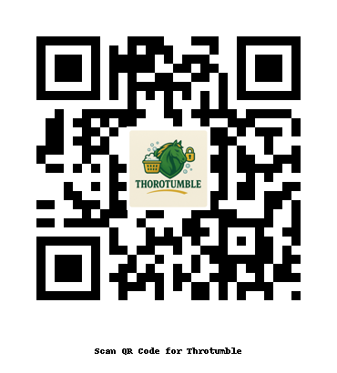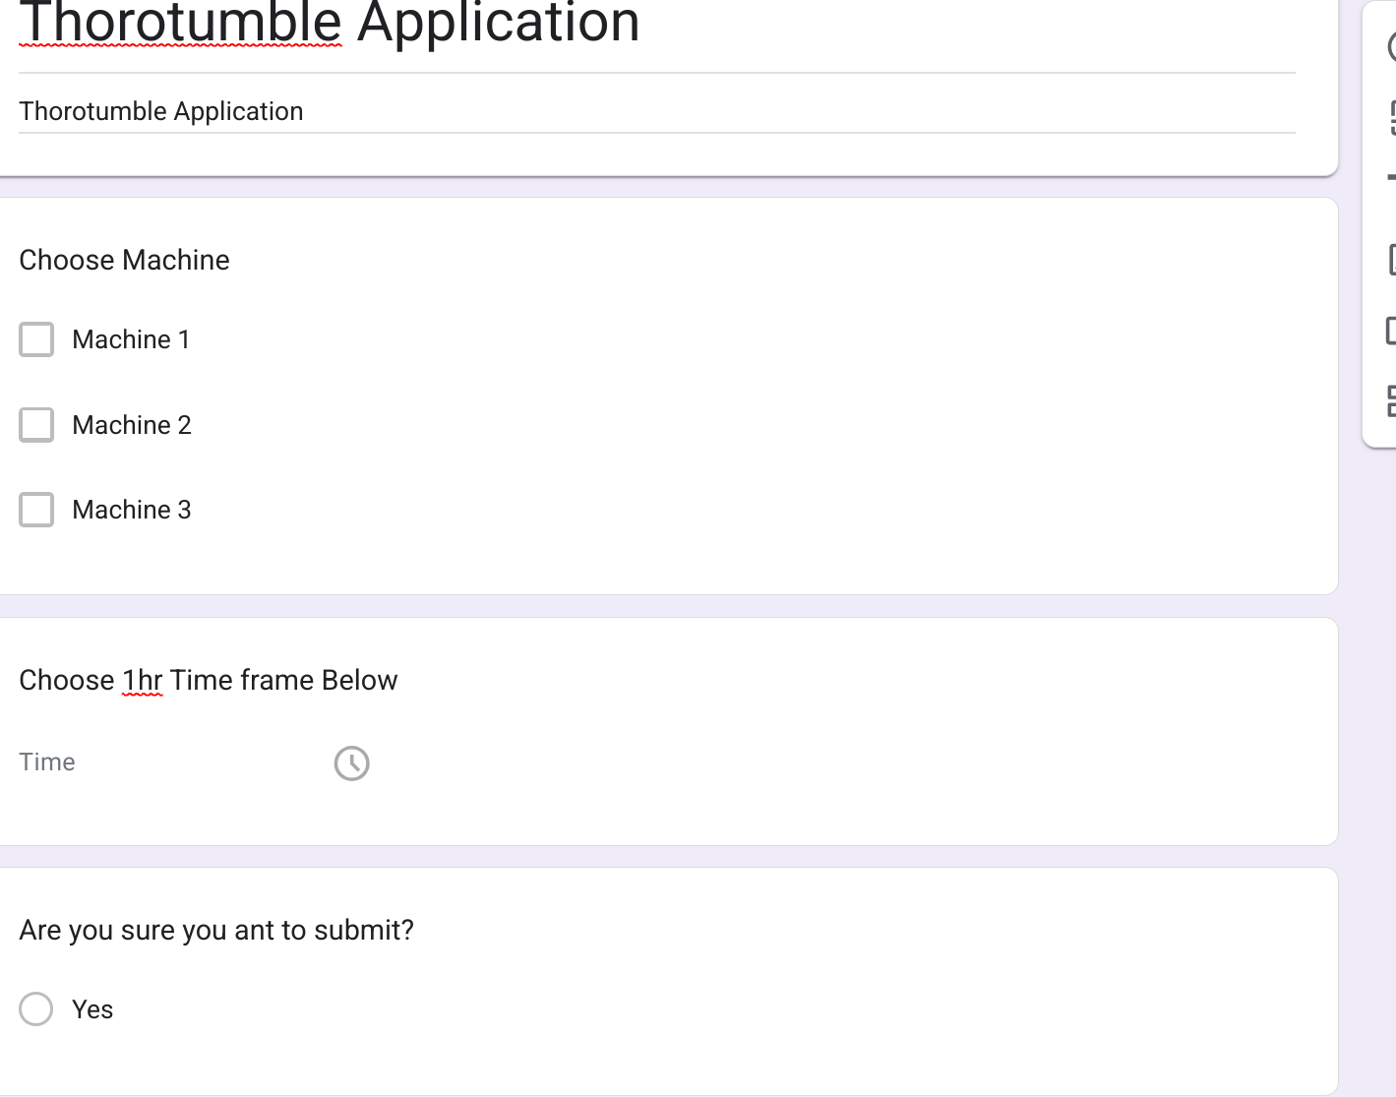

4. UI/UX Design Document

THOROTUMBLE – UI/UX DESIGN DOCUMENT

Purpose
This document explains the user interface design, experience principles, layout logic, and accessibility considerations used for ThoroTumble.

UI Design Choices

Colors
- Green tones → represent Kentucky State University themes & cleanliness
- Yellow highlights → represent security (lock icon) and KSU branding

Typography
- Bold headings for clarity
- Sans-serif fonts for readability

Layout
- Home page with large logo
- Simple machine grid layout
- Large buttons for mobile friendliness

UX Principles Applied

1. Simplicity
Users only need to complete one task: reserving a machine.

2. Accessibility
- Large buttons
- High-contrast colors
- QR code for mobile access

3. Consistency
All screens follow the same color theme and button style.

4. Visual Cues
Icons used to represent:
- Machine
- Time
- Lock/security

